United, Alaska find loose parts on 737 MAX planes, raising pressure on Boeing

By [Valerie Insinna](https://www.reuters.com/authors/valerie-insinna/), [David Shepardson](https://www.reuters.com/authors/david-shepardson/) and [Rajesh Kumar Singh](https://www.reuters.com/authors/rajesh-kumar-singh/)

January 8, 20249:03 PM PSTUpdated 4 months ago

[Captions auto-generated & unedited.]

The plotter of an Alaska

0 seconds of 15 secondsVolume 0%

Missing part of Alaska Airlines jet found in backyard

* Summary
* Companies
* Alaska initial checks show some 'loose hardware' visible
* United finds problems with more doors during inspections-source
* Unclear when 737 MAX 9 jets will return to service
* Industry concerns about aircraft deepen
* Boeing shares fall 8%

WASHINGTON/CHICAGO, Jan 8 (Reuters) - Boeing's latest 737 MAX crisis deepened after United Airlines and Alaska Airlines said they had found loose parts on multiple grounded MAX 9 aircraft, raising new concerns among industry experts about how its best-selling jet family is manufactured.

U.S. regulators grounded 171 MAX 9 planes after a panel [blew off](https://www.reuters.com/business/aerospace-defense/what-is-panel-that-blew-off-boeing-plane-mid-air-2024-01-07/) an Alaska Airlines-operated flight not long after taking off from a Portland, Oregon, airport on Friday, forcing pilots to scramble to land the plane safely.

Alaska Airlines [(ALK.N), opens new tab](https://www.reuters.com/markets/companies/ALK.N) said late on Monday that initial reports from its technicians indicated some "loose hardware" was visible on some aircraft in the relevant area when it conducted checks of its fleet.

It was waiting for final documentation from Boeing [(BA.N), opens new tab](https://www.reuters.com/markets/companies/BA.N) and the U.S. Federal Aviation Administration (FAA) before formal inspections could begin.

United [(UAL.O), opens new tab](https://www.reuters.com/markets/companies/UAL.O), the other U.S. carrier that flies this Boeing model with the panels, said its preliminary checks found bolts that needed tightening on several panels.

The disclosures heightened concerns about the production process of the MAX 9 jets that have been grounded.

A source familiar with the matter said United has so far found close to 10 airplanes with loose bolts during its preliminary checks, up from an initial five first reported by industry publication The Air Current, and the figure may increase.

There are still ongoing discussions between Boeing, the FAA and the airlines on the precise inspection guidelines.

Boeing [(BA.N), opens new tab](https://www.reuters.com/markets/companies/BA.N) is expected to revise the guidelines it submitted to airlines earlier on Monday, and the FAA would have to sign off on those changes before the airlines could begin repairs, sources said.

Boeing said it was staying in close contact with MAX 9 operators and would help customers address any findings during inspections.

"We are committed to ensuring every Boeing airplane meets design specifications and the highest safety and quality standards," the planemaker said. "We regret the impact this has had on our customers and their passengers."

Several industry insiders said airlines have started to hear passengers voice concerns about the safety of the aircraft, even though the MAX 9 in question is only used by a handful of carriers.

Any prolonged concerns may increase pressure on Boeing, which has suffered from numerous [production issues](https://www.reuters.com/business/aerospace-defense/mid-air-blowout-puts-boeing-back-hot-seat-2024-01-07/) since the wider grounding of the 737 MAX family in March 2019 that lasted 20 months after two deadly crashes killed 346 people.

"This changes a lot because it is now a fleet problem. This is a quality control problem," said U.S. aircraft safety expert John Cox.

Investigators said on Sunday it was too early to determine the cause.

[Boeing shares sank](https://www.reuters.com/business/aerospace-defense/boeing-shares-slide-frankfurt-after-faa-grounds-some-max-9s-2024-01-08/) 8% on Monday.

FLIGHT CANCELLATIONS

Boeing's largest single-aisle model in production has a panel known as a door plug to replace an exit that would be installed on planes configured to carry more passengers. Most operators use the lower-density version with the door plug.

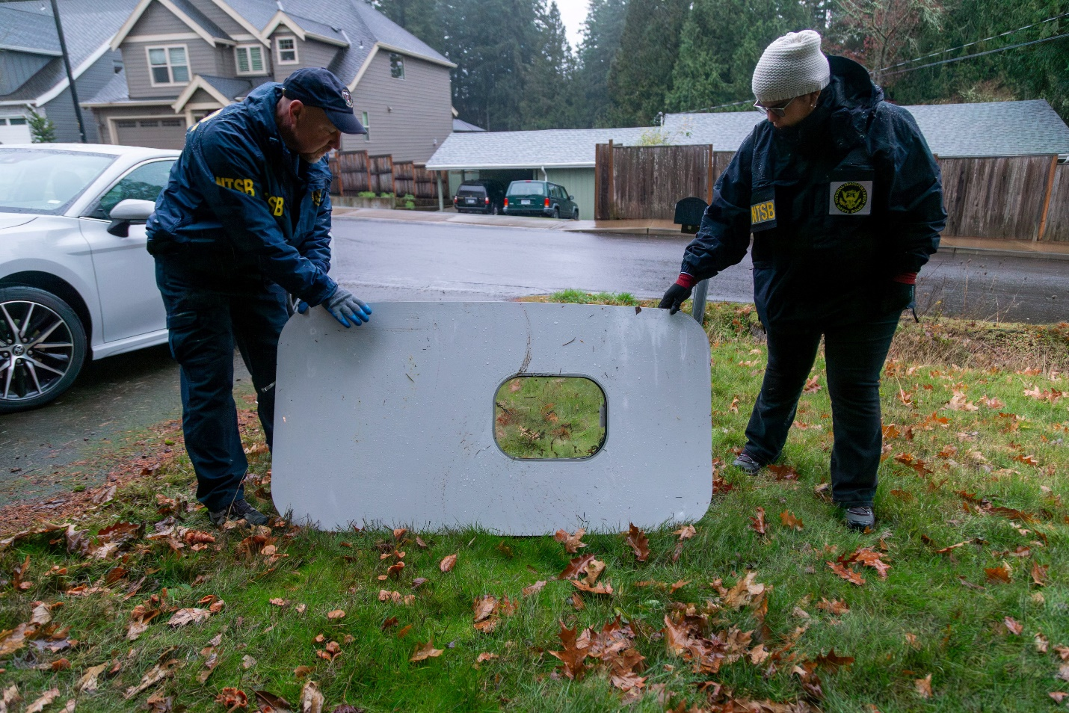

Item 1 of 9 National Transportation Safety Board (NTSB) investigators examine the fuselage plug area of Alaska Airlines Flight 1282 Boeing 737-9 MAX, which was jettisoned and forced the aircraft to make an emergency landing, at a property where it was recovered in Portland, Oregon, U.S. January 8, 2024. NTSB/Handout via REUTERS.

[1/9]National Transportation Safety Board (NTSB) investigators examine the fuselage plug area of Alaska Airlines Flight 1282 Boeing 737-9 MAX, which was jettisoned and forced the aircraft to make an emergency landing, at a property where it was recovered in Portland, Oregon, U.S. January 8, 2024. ... [*Purchase Licensing Rights, opens new tab*](https://www.reutersagency.com/en/licensereuterscontent/?utm_medium=rcom-article-media&utm_campaign=rcom-rcp-lead) Read more

People familiar with the process have said the panel is fitted in two stages, first by supplier Spirit AeroSystems [(SPR.N), opens new tab](https://www.reuters.com/markets/companies/SPR.N) and later completed by Boeing. Investigators said they would examine both manufacturing and maintenance records.

Spirit shares fell 11% on Monday.

The FAA declined to comment on the loose bolt reports.

"Since we began preliminary inspections on Saturday, we have found instances that appear to relate to installation issues in the door plug – for example, bolts that needed additional tightening," United said in a statement.

Once the final process is approved by the FAA, inspections are expected to take several days, forcing the cancellation of numerous flights. One senior industry source said the timing was increasingly unpredictable and that the FAA, under a recently appointed leader, would be cautious.

The FAA said planes would remain grounded "until operators complete enhanced inspections which include both left and right cabin door exit plugs, door components, and fasteners."

Alaska Airlines pilots on Friday turned the plane around and landed it safety, and no major injuries were reported even as oxygen masks deployed and personal items were [sucked out](https://www.reuters.com/business/aerospace-defense/mid-air-blowout-puts-boeing-back-hot-seat-2024-01-07/) of the plane.

"It was really important to figure out whether it was that specific aircraft from Friday night," said Anthony Brickhouse, an air safety expert at Embry-Riddle Aeronautical University.

"The fact that United has now found some aircraft with loose bolts, that just means that the investigation is going to be expanded."

A diagram of the 737 MAX 9 door plug posted by the U.S. National Transportation Safety Board on Sunday shows four bolts - two in the upper corners of the plug and two lower hinge brackets - that secure the plug to the fuselage.

The plug is further fastened in place by "stop fittings" at 12 different locations along the side of the plug and the door frame. Those components hold the door plug in place and prevent it from being pushed out of the airframe.

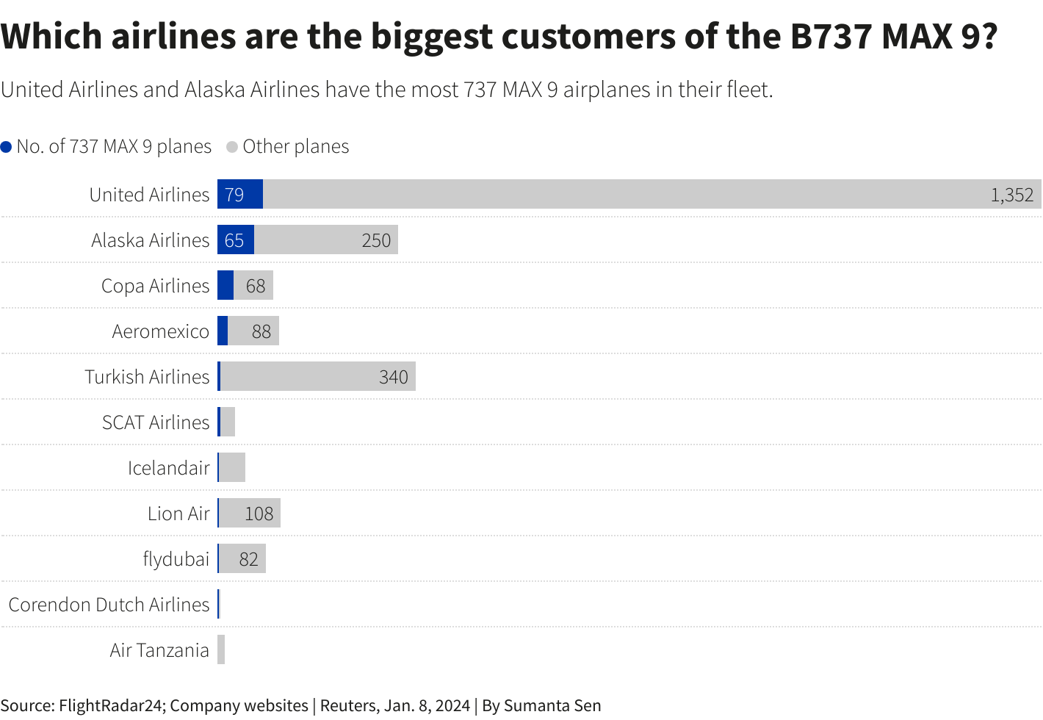

Reuters Graphics

PANEL FOUND IN BACKYARD

The panel was [recovered](https://www.reuters.com/business/aerospace-defense/no-data-captured-alaska-airlines-737-cockpit-voice-recorder-ntsb-chair-2024-01-08/) on Sunday by a [Portland schoolteacher](https://www.reuters.com/world/us/oregon-schoolteacher-finds-missing-boeing-plane-part-backyard-trees-2024-01-09/) who found it in his backyard, NTSB Chair Jennifer Homendy said.

Homendy said the cockpit voice recorder did not capture any data because it had been [overwritten](https://www.reuters.com/business/aerospace-defense/alaska-737-cockpit-voice-recorder-data-erasure-renews-industry-safety-debate-2024-01-08/). She again [called](https://www.reuters.com/business/aerospace-defense/alaska-737-cockpit-voice-recorder-data-erasure-renews-industry-safety-debate-2024-01-08/) on regulators to mandate retrofitting existing planes with recorders that capture [25 hours of data, opens new tab](https://statics.teams.cdn.office.net/evergreen-assets/safelinks/1/atp-safelinks.html), up from the two hours required in the U.S. at present.

Alaska Airlines cancelled 141 flights, or 20% of its scheduled departures, on Monday after grounding its 65 MAX 9s. The carrier said travel disruptions were expected to last through at least mid-week. United, which has grounded its 79 MAX 9s, cancelled 226 flights on Monday, or 8% of its scheduled departures.

Of the 171 planes covered by the order, 144 are operating in the United States, aviation analytics firm Cirium said.

Turkish Airlines, Panama's Copa Airlines and Aeromexico said they had grounded affected jets. Indonesia said it had suspended the use of three jets not covered by the order.